Running Example
Two Relations R and S
T(R) = 60000
T(S) = 2000
Block size = 4000 bytes
S(R) = 100 bytes
S(S) = 500 bytes
Main Memory = 126 Buffers

Example 1a: Join Selection for Large Relations
Two Relations R and S:
- T(R)=80,000, T(S)=3,000
- Block size = 4000 bytes, S(R)=120, S(S)=600 bytes
- Main Memory = 150 Buffers
Given the above details, what join algorithm would you suggest? Calculate the total number of I/O operations required.

Example 1b: Join Selection for Medium Relations
Two Relations R and S:
- T(R)=30,000, T(S)=1,500, Block size = 4000 bytes, S(R)=80 bytes
- S(S)=400 bytes, Main Memory = 100 Buffers
Given the above details, what join algorithm would you suggest? Calculate the total number of I/O operations required.

Example 1c: Join Selection for Small Relations
Two Relations R and S:
- T(R)=5,000, T(S)=500, Block size = 4000 bytes, S(R)=100 bytes, S(S)=500 bytes
- Main Memory = 50 Buffers
Given the above details, what join algorithm would you suggest? Calculate the total number of I/O operations required.

Explanation of Concepts in the Questions
- Tuple Count T(R) and T(S): The number of tuples in each relation.
- Block Size: The size of each block in bytes.
- Tuple Size (S(R) and S(S)): The size of each tuple in bytes.
- Main Memory Buffers: The number of buffers available in main memory for processing.
These questions test understanding of:
- Join Algorithm Selection: Choosing the most efficient join algorithm (e.g., nested loop join, sort-merge join, hash join) based on the given parameters.
- I/O Operations: Calculating the total number of disk I/O operations required for the join.

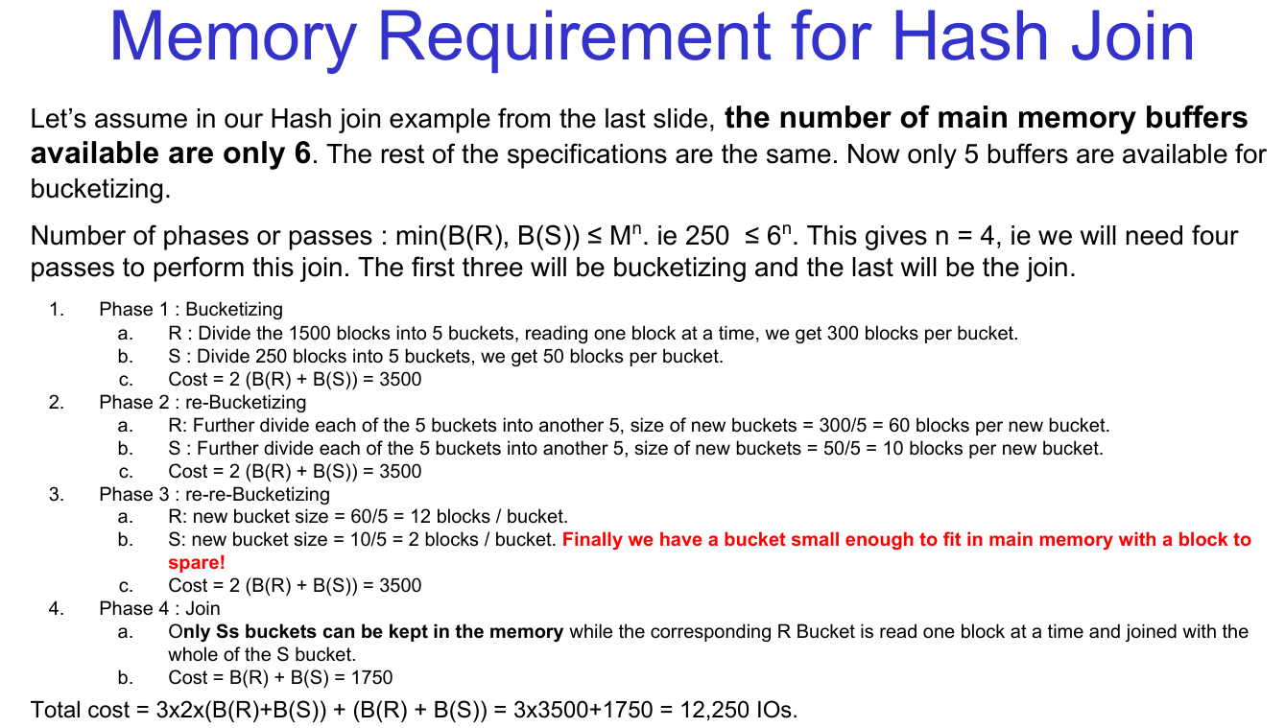

Question 1a: Hash Join with Limited Memory
Let’s assume in a Hash Join example, the number of main memory buffers available is only 8. The rest of the specifications are as follows: B(R)=2000 blocks, B(S)=500 blocks, Number of buffers for bucketizing: 7
a) Calculate the number of phases or passes required for the Hash Join.
b) Describe the bucketizing process for each phase and calculate the I/O cost for each phase.
c) What is the total I/O cost for the entire Hash Join operation?

Question 1b: Hash Join with Smaller Relations
Let’s assume in a Hash Join example, the number of main memory buffers available is only 5. The rest of the specifications are as follows: B(R)=1000 blocks, B(S)=200 blocks, Number of buffers for bucketizing: 4
a) Calculate the number of phases or passes required for the Hash Join.
b) Describe the bucketizing process for each phase and calculate the I/O cost for each phase.
c) What is the total I/O cost for the entire Hash Join operation?
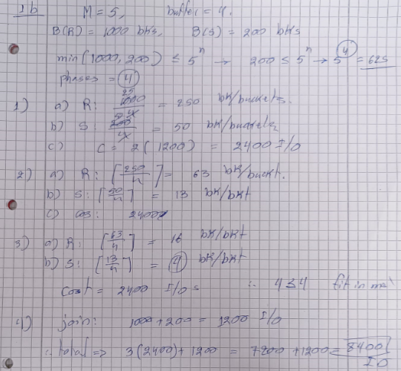

Question 1c: Hash Join with Larger Relations
Let’s assume in a Hash Join example, the number of main memory buffers available is only 10. The rest of the specifications are as follows: B(R)=3000 blocks, B(S)=1000 blocks, Number of buffers for bucketizing: 9
a) Calculate the number of phases or passes required for the Hash Join.
b) Describe the bucketizing process for each phase and calculate the I/O cost for each phase.
c) What is the total I/O cost for the entire Hash Join operation?

Explanation of Concepts in the Questions
- Hash Join: A join algorithm that uses hashing to partition relations into smaller buckets that fit in memory.
- Phases or Passes: The number of times data must be read/written to disk during bucketizing and joining.
- Bucketizing: Dividing the relations into smaller buckets using a hash function.
- I/O Cost: The total number of disk I/O operations required for the join, calculated as:
  - Bucketizing Cost: 2×(B(R)+B(S)) per phase.
  - Join Cost: B(R)+B(S) for the final join phase.

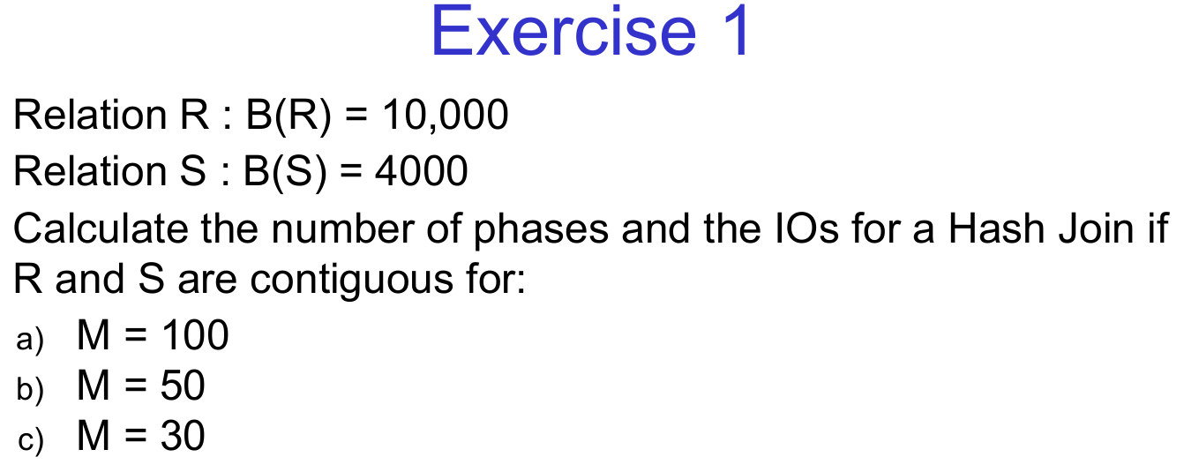

Exercise 1a
Relation R: B(R)=12,000. Relation S: B(S)=5,000
Calculate the number of phases and the I/O cost for a Hash Join if R and S are contiguous for:
a) M=120, b) M=60, c) M=40

Exercise 1b
Relation R: B(R)=15,000 Relation S: B(S)=6,000
Compute the number of phases and the I/O cost for a Hash Join if R and S are contiguous for:
a) M=150, b) M=80, c) M=50

Exercise 1c
Relation R: B(R)=8,000 Relation S: B(S)=3,500
Determine the number of phases and the I/O cost for a Hash Join if R and S are contiguous for:
a) M=90 b) M=45 c) M=25

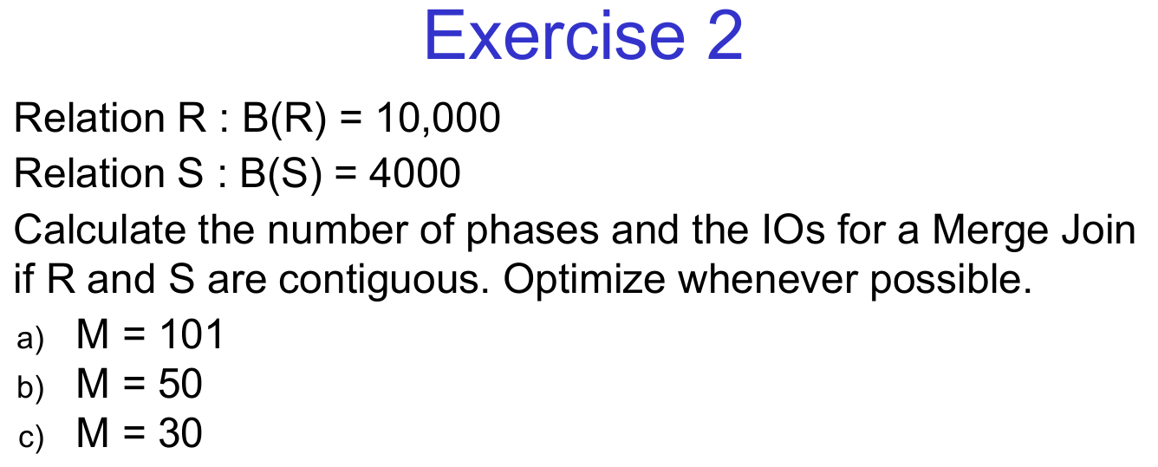
Exercise 2a
Relation R: B(R)=12,000 Relation S: B(S)=5,000
Calculate the number of phases and the I/O cost for a Merge Join if R and S are contiguous. Optimize whenever possible.
a) M=120 b) M=60 c) M=40

Exercise 2b
Relation R: B(R)=15,000 Relation S: B(S)=6,000
Calculate the number of phases and the I/O cost for a Merge Join if R and S are contiguous. Optimize whenever possible.
a) M=150 b) M=80 c) M=50

Exercise 2c
Relation R: B(R)=8,000 Relation S: B(S)=3,500
Calculate the number of phases and the I/O cost for a Merge Join if R and S are contiguous. Optimize whenever possible.
a) M=90 b) M=45 c) M=25

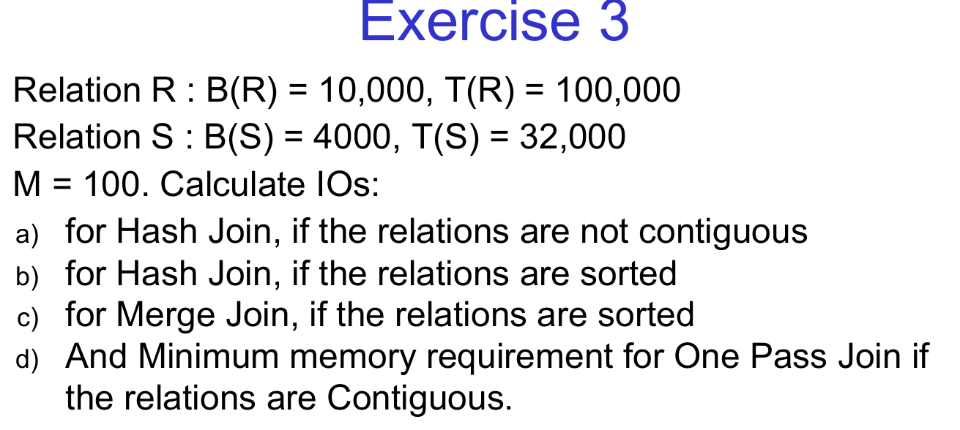

Exercise 3a
Relation R: B(R)=12,000, T(R)=120,000. Relation. S: B(S)=5,000, T(S)=40,000 Available main memory blocks: M=120
Calculate the I/O costs for:
a) Hash Join when the relations are not contiguous.
b) Hash Join when the relations are sorted.
c) Merge Join when the relations are sorted.
d) The minimum memory requirement for One-Pass Join when the relations are contiguous.

Exercise 3b
Relation R: B(R)=15,000, T(R)=150,000. Relation S: B(S)=6,000, T(S)=48,000. Available main memory blocks: M=150
Calculate the I/O costs for:
a) Hash Join if the relations are not contiguous.
b) Hash Join if the relations are already sorted.
c) Merge Join if both relations are sorted.
d) The minimum memory requirement for a One-Pass Join, assuming contiguous storage.

Exercise 3c
Relation R: B(R)=8,000, T(R)=80,000. Relation. S: B(S)=3,500, T(S)=28,000. Available main memory blocks: M=80
Compute the I/O costs for:
a) Hash Join if the relations are not stored contiguously.
b) Hash Join if both relations are sorted.
c) Merge Join assuming the relations are sorted.
d) The minimum memory requirement for a One-Pass Join when the relations are contiguous.

Joins: Iteration vs. Hash vs. Merge
Joins are a fundamental operation in relational databases, used to combine records from two or more tables based on a common key. There are multiple ways to implement joins efficiently, depending on the size of the tables, availability of indexes, and amount of memory available.
The three major types of join algorithms are:
- Nested Loop Join (Iteration-based Join)
- Hash Join
- Merge Join (Sort-Merge Join)

1. Nested Loop Join (Iteration-based Join)

Concept:
This is the most basic way to perform a join. It involves iterating through one relation (outer loop) and, for each row, scanning the entire second relation (inner loop) to find matching tuples.

Types:
- Brute Force Nested Loop: No indexing, scanning every combination of tuples.
- Indexed Nested Loop: Uses an index on the inner relation to speed up lookups.
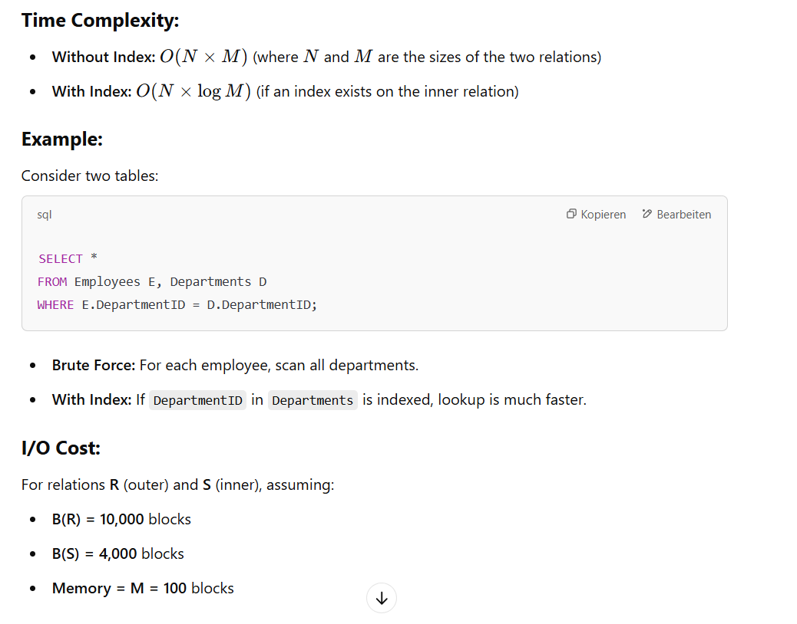
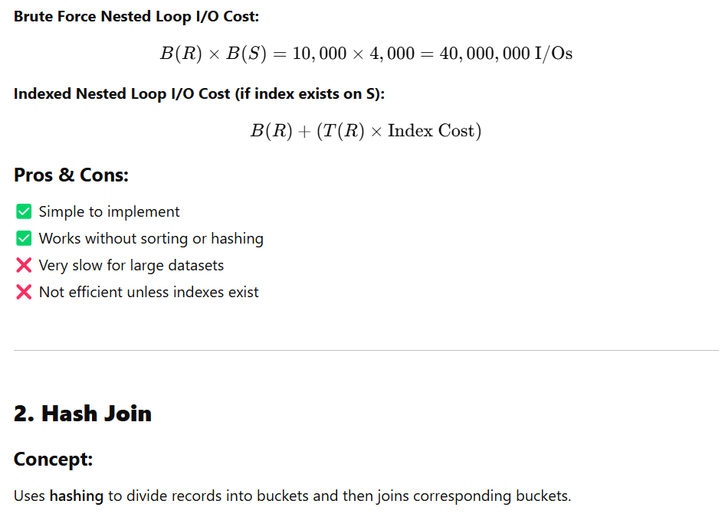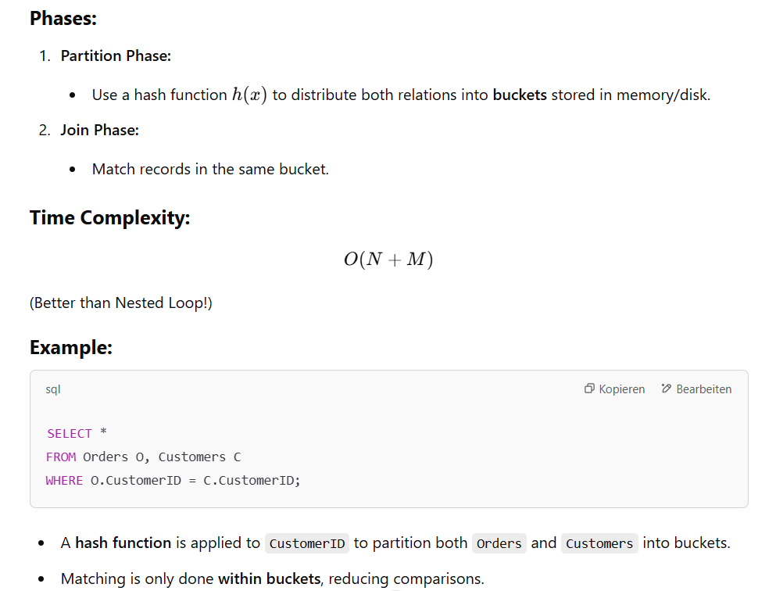
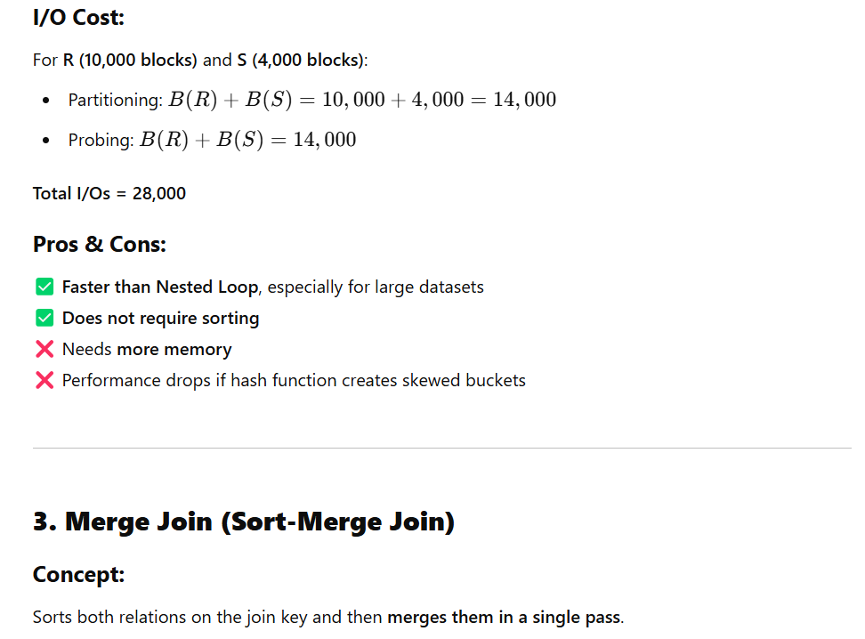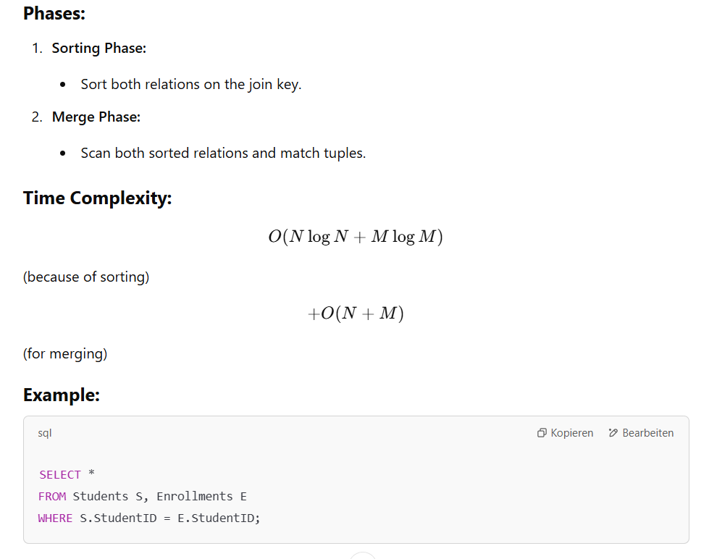
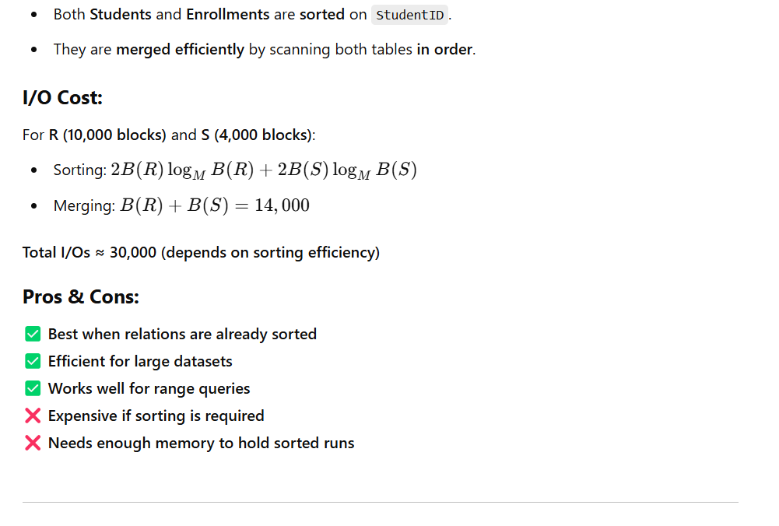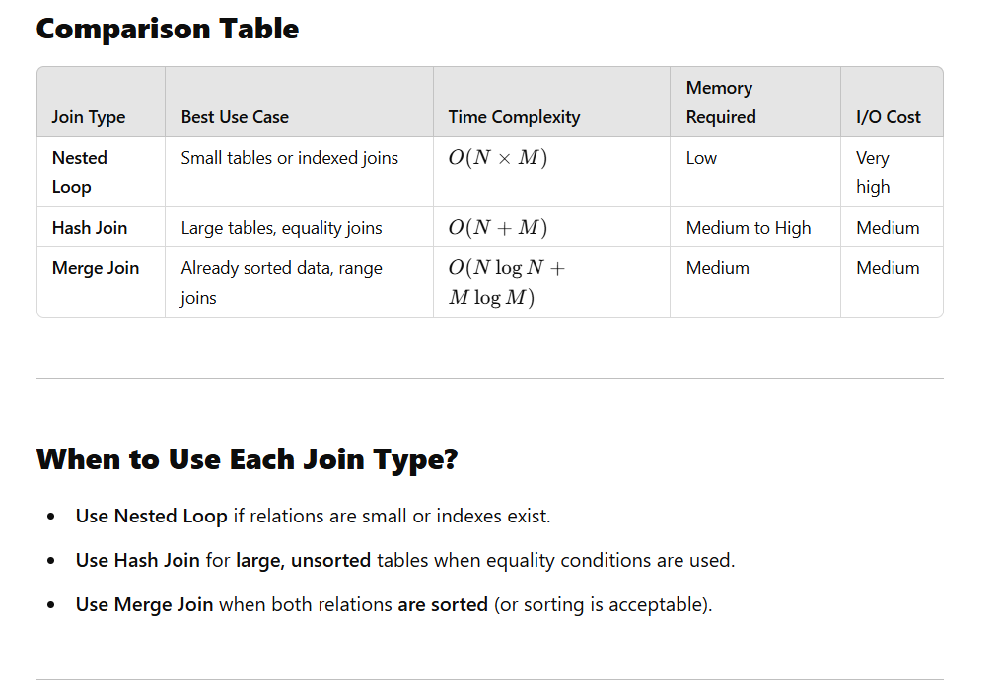
Conclusion
Joins are a critical operation in query processing, and choosing the right algorithm is crucial for performance.
- Nested Loop is simple but inefficient.
- Hash Join is fast for large, unsorted data.
- Merge Join is great for sorted relations.

“DBMS 10 Joins v2.pdf” and I’ll now teach you all the topics step by step, with detailed explanations, worked examples, and a summary at the end.

📘 Topics in This Note
- Types of Join Algorithms
  - Iteration Join (Nested Loop Join)
  - Merge Join
  - Hash Join
  - Index Join (briefly mentioned)
- Factors Affecting Join Performance
  - Cost of I/O operations
  - How relations are stored (contiguous vs non-contiguous, clustering vs non-clustering index)
- Detailed Join Algorithm Analysis
  - IO cost formulas
  - Worked examples with relations R and S
  - Improvements when multiple buffers are available
- Merge Join
  - Normal case
  - With sorting
  - Optimizations when sublists fit into memory
- Hash Join
  - Bucketizing
  - Cost phases
  - Memory requirements and re-bucketizing
  - Example calculations
- One-Pass Join
- Comparative Costs
- Exercises & Solutions

1. Join Algorithms

🔹 Iteration Join (Nested Loop Join)
- Basic Idea: For each tuple in relation R, scan all tuples in S to find matches.
- Cost (non-contiguous storage):
Cost = T(R) + T(R) × T(S)
Example: R=60000, S=2000 → cost = 120,060,000 I/Os (very expensive!).
- Improvement: Use multiple buffers. If memory can hold many tuples of R at once, scan S fewer times.
Example with 126 buffers → reduced cost from 120 million → 84,000 I/Os.

🔹 Merge Join
- Requirement: Both relations must be sorted on the join attribute.
- Algorithm: Like merging two sorted arrays → linear scan of both relations.
- Cost:
Join cost=B(R)+B(S)
- If not sorted → need multiway merge sort first.
Sorting cost = 2×(B(R)+B(S)).
- Optimization: Sometimes we can skip the final sorting phase and directly perform join if total sublists ≤ available buffers.

🔹 Hash Join
- Phase 1 (Bucketizing):
  - Apply hash function on join attribute.
  - Partition both R and S into buckets.
  - Cost: 2×(B(R)+B(S))
- Phase 2 (Joining):
  - Compare only corresponding buckets (R1 with S1, R2 with S2…).
  - Cost: B(R)+B(S)
- Memory Consideration:
  - Works in 2 passes if min⁡(B(R),B(S))≤M^2
  - Else requires re-bucketizing (multi-pass).
- Example: R=1500 blocks, S=250 blocks, M=126 →
Total cost = 5250 I/Os (much better than iteration join).

🔹 One-Pass Join
- If one relation can completely fit in memory (M ≥ min(B(R),B(S))+1):
  - Keep smaller relation in memory.
  - Scan the larger relation once.
- Cost:
B(R)+B(S)B(R) + B(S)

2. Factors Affecting Performance
- Contiguous storage: Fetching a block gets many tuples at once.
- Non-contiguous storage: Each block may hold only one tuple → much more expensive.
- Clustering Index: Tuples with same key likely together.
- Non-Clustering Index: Tuples with same key scattered → 1 I/O per record.

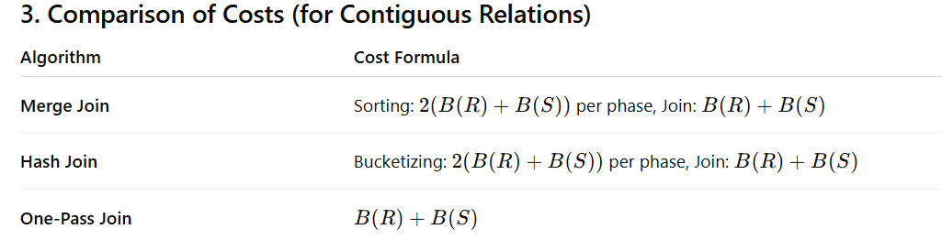

4. Worked Example (from notes)
Relations:
- T(R)=60,000, T(S)=2000
- Block size = 4000 bytes
- S(R)=100 bytes → 40 records/block → B(R)=1500 blocks
- S(S)=500 bytes → 8 records/block → B(S)=250 blocks
- M=126 buffers

Results:
- Iteration Join (improved) → 84,000 I/Os
- Merge Join (with sorting) → 8750 I/Os
- Hash Join → 5250 I/Os
- One-pass Join (if possible) → 1750 I/Os

5. Exercises
The PDF includes exercises applying the above formulas for different buffer sizes (M=100, 50, 30, etc.) and shows how phases differ for hash join vs merge join.

✅ Summary
- Iteration Join = simplest but very costly unless memory is heavily used.
- Merge Join = great if relations are sorted; otherwise cost includes sorting.
- Hash Join = efficient and often better than merge if data isn’t sorted.
- One-Pass Join = most efficient, but only possible if one relation fits in memory.
- Cost depends heavily on: storage organization (contiguous vs non-contiguous), indexes, block size, and memory buffers.

📝 Practice Problems on Join Algorithms

Problem 1: Iteration Join (Nested Loop Join)
Two relations R and S are given:
- T(R)=10,000T(R) = 10,000 tuples, size of each = 100 bytes
- T(S)=2,000T(S) = 2,000 tuples, size of each = 200 bytes
- Block size = 1000 bytes
- Available memory = 20 buffers
Tasks:
- Compute cost if both relations are stored non-contiguously.
- Compute cost if both relations are contiguously stored, and memory is fully utilized.

✅ Solution:
- For non-contiguous:
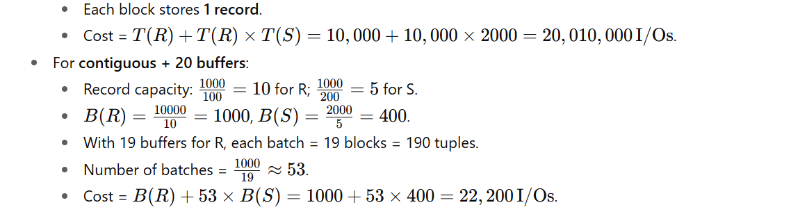

Problem 2: Merge Join
Relations:
- B(R)=5000, B(S) = 2000.
- Memory M=50.
Tasks:
- Compute cost if both relations are already sorted.
- Compute cost if relations are unsorted.

✅ Solution:

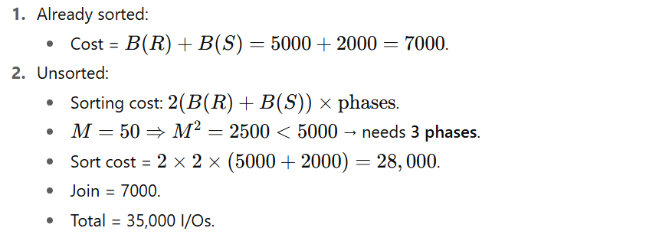

Problem 3: Hash Join
Relations:
- B(R)=1500B(R) = 1500, B(S)=500B(S) = 500.
- Memory M=40M=40.
Task:
Compute the cost of performing a hash join.

✅ Solution:
- Condition: min⁡(B(R),B(S))≤M2\min(B(R),B(S)) \leq M^2.
- Here: min⁡(1500,500)=500\min(1500,500) = 500, M2=1600M^2 = 1600. ✅ Condition satisfied → 2 phases.
- Bucketizing: 2(B(R)+B(S))=2(1500+500)=40002(B(R)+B(S)) = 2(1500+500) = 4000.
- Join: B(R)+B(S)=2000B(R)+B(S) = 2000.
- Total = 6000 I/Os.

Problem 4: One-Pass Join
Relations:
- B(R)=1200B(R)=1200, B(S)=100B(S)=100.
- Memory M=150M=150.
Task:
Check if a one-pass join is possible. If yes, compute the cost.

✅ Solution:
- Requirement: M≥min⁡(B(R),B(S))+1=101M \geq \min(B(R),B(S)) + 1 = 101.
- Here, M=150M=150 → condition satisfied.
- Cost = B(R)+B(S)=1200+100=1300B(R)+B(S) = 1200+100 = 1300.

